Lab 07

COS20019

CLOUD COMPUTING ARCHITECTURE

Tran Thanh Minh

Task 1: Create an AMI for auto scaling

1. Creating AMI A screenshot of a computer

   Description automatically generated

Taks 2: Create a Load Balancer

1. Configure target groups base on the instruction from the labA screenshot of a computer

   Description automatically generated with medium confidence
2. Configure network mapping for the Application Load Balancer with the selection of both public subnets A screenshot of a computer

   Description automatically generated
3. Configure security groups and listeners and routing section for the load balancer A screenshot of a computer

   Description automatically generated with medium confidence

Task 3: Create a Launch Template and Auto scaling group

1. Create launch template A screenshot of a computer

   Description automatically generated
2. Configure Application and OS images and instance type sections A screenshot of a computer

   Description automatically generated
3. Configure network setting for the templateA screenshot of a computer

   Description automatically generated with medium confidence
4. Enable detailed cloud watch monitoring for allowing auto scaling to react quickly to changing utilization. A screenshot of a computer

   Description automatically generated with medium confidence
5. Create auto scaling group A screenshot of a computer

   Description automatically generated
6. Configure the network for the auto scaling group A screenshot of a computer

   Description automatically generated with medium confidence
7. Attach it to the load balancer have been created before , and enable the group metrics collection within cloudwatch.A screenshot of a computer

   Description automatically generated
8. Configure group size and scaling policies to ensure auto scaling automatically add/remove instance and always keep between 2 and 6 instances running.A screenshot of a computer

   Description automatically generated

Task 4: Verify that load balancing is working

1. Both instances has passed the load balancer’s health check A screenshot of a computer

   Description automatically generated
2. Get the DNS name of the load balancer A screenshot of a computer

   Description automatically generated with medium confidence
3. The result of going to the DNS page A screenshot of a computer

   Description automatically generated

Task 5: Test auto scaling

1. Implement load test 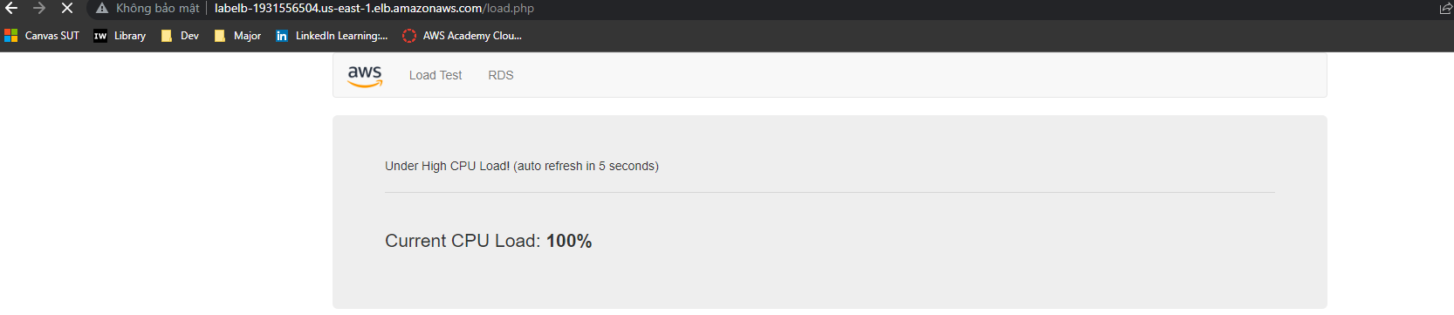
2. The state change A screenshot of a computer

   Description automatically generated with medium confidence
3. More than 2 instances are running A screenshot of a computer

   Description automatically generated with medium confidence

Task 6: terminate web server 1

1. A screenshot of a computer

   Description automatically generated